**Kickstarter Campaign Analysis**

By Abbey Reese

**Purpose**

The purpose of this analysis is to utilize knowledge of pivot tables and graphing in Excel to visualize campaign outcomes based on launch date and to use Excel skills to visualize the percentage of successful, failed, and canceled plays based on the funding goal amount.

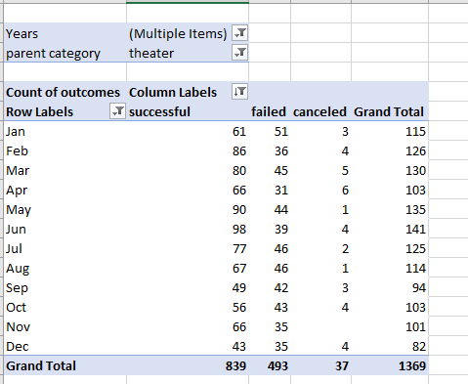**Analysis**

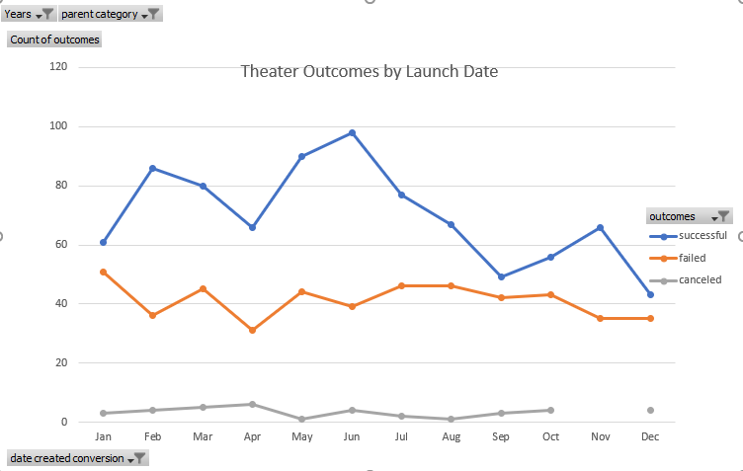The analysis was performed by creating a pivot table with the necessary information needed from an already-given datasheet. It Included the outcomes: successful, failed, or cancelled. There was then a line graph made utilizing this information including historical months and years to provide a visual for the information needed to assess the best month to start a campaign.

**Challenges**

Possible challenges would be unreliable data, or if most were cancelled for reasons outside of a controlled group. If it just 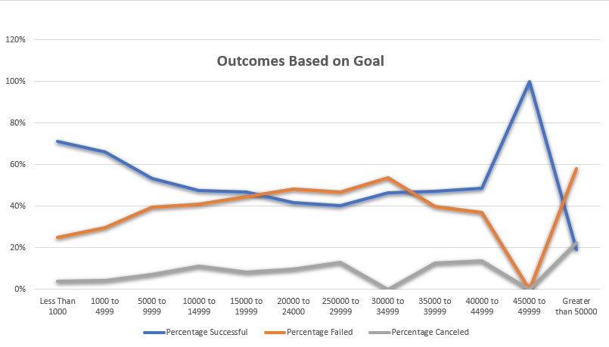so happened that the data was only for the year of the pandemic for instance, that data would be skewed for that year specifically, not as a whole. Looking at the charts created in hindsight, it would be better visually if they were the same format.

**Conclusions**

The two conclusions that one can draw from the Theater Outcomes and Launch Date is that June seemed to be the most successful month to start a campaign as it had the highest successful ratings and a lower comparative gap (to other months), failed campaign start date. The two conclusions that one can draw from Outcomes based on Goals is that $45,000-$49,999 goal amount carried both the highest and lowest (excluding cancelled) outcomes based on funding amount.

**Limitations**

Some limitations to this dataset may be possible inaccuracy in collecting data, and definition of successful and failed campaign meaning.

**Other Useful Information**

Other tables we could create would be comparing this campaign to other types of campaigns, arts or political for instance to get a better visualization on just how much this type of thing costs.